**Probabilistic class label**

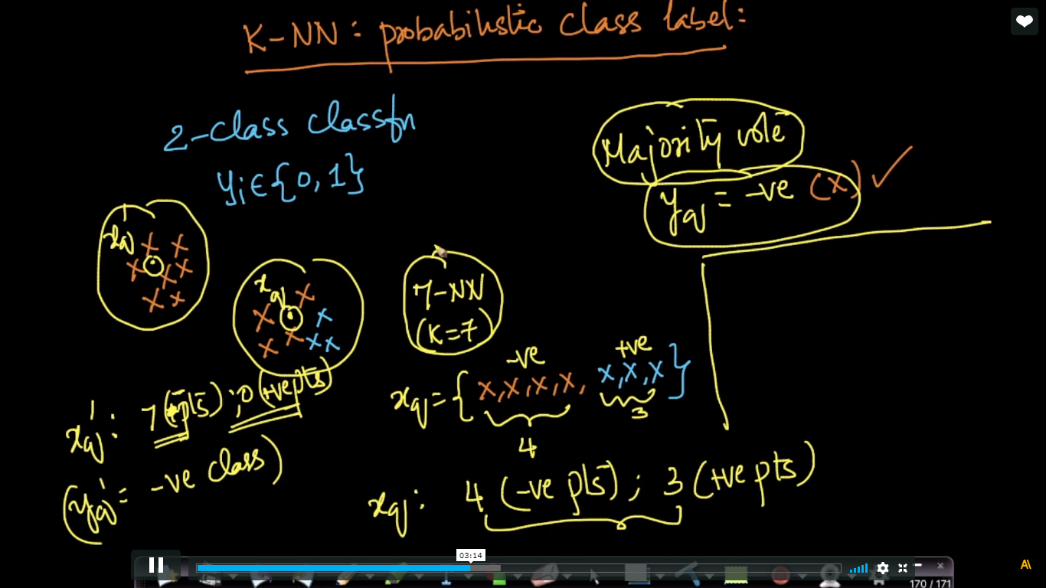

Suppose we are applying 7-nn, As we see in xq we predict it –ve because there are 4 –ve and 3 +ve points but its not fair because diff. b/w +ve and –ve pts. Are very less. Therefore it is uncertain now to quantify this uncertainity what we de is shown in below image.

P(Yq = -ve) = 4/7(i.e we can say that probab. Of pts. To be negative is 4/7)

Similarly for +ve.

Now in Xq’ as all 7 points are negative therefore it is more certain because probability of Yq’ to be –ve is 100%

